PRESS RELEASE
Working platform for the repair of rotor blades demonstrated on offshore wind turbine
SYSTEM terra convinces in operation on a SWT-3.6
Hamburg, 13 March 2020. WINDEA Offshore, together with its partner WP Systems, has taken another step towards establishing the WINDEA Blade Service concept. Last week the operation of the working platform SYSTEM terra was successfully demonstrated at a Siemens SWT-3.6 offshore test turbine in the German district of Nordfriesland. The platform, which is used for maintenance and repair of rotor blades, has thus proven its functionality for the first time on an offshore wind turbine. About 30 representatives of different manufacturers as well as of some of the largest operators of offshore wind farms followed the invitation of WINDEA Offshore and took an active part in the demonstration.
The SYSTEM terra working platform developed for the rotor blade repair of onshore turbines has already been tested on the market for two years and is in continuous operation within the Buss Energy Group. The platform, which is completely protected from weather, enables technicians to carry out repairs around the entire rotor blade all year around. Work on the blade is performed at wind speeds of up to 12.5 m/s and 24/7 in a temperature- and humidity-controlled environment.
The SYSTEM terra working platform is already being modified to meet special offshore requirements and further developed into the SYSTEM aqua. The corrosion protection of the platform as well as the conditions of the offshore turbines play an important role. Among other things, the different dimensions of the foundation structures, the anchor points for rope attachments and also the bending of the rotor blades must be taken into account.
Ole Renner, CEO of WP Systems: "The personal exchange with manufacturers and operators has shown that we are absolutely on the right track. The feedback on the functionality and processing of our maintenance system was extremely positive. Once again it became clear to me how important such live demonstrations are".
The on-site demonstration not only provided customers with a presentation of the WINDEA Blade Service concept and an inspection of the maintenance system. Rather, all participants were able to move along the offshore rotor blade at the platform themselves and thus gained an exclusive insight into the optimal working conditions. Martin Frederiksen, Integrity Specialist at Ørsted: „Safety and reliability are our top priorities. With this working platform we see the conditions fulfilled and could imagine using such a system for our maintenance and repair works.“
WINDEA Blade Service
WINDEA Offshore has developed a comprehensive concept together with its shareholders and its new partner WP Systems that makes the repair of rotor blades offshore safer, more efficient and cost-effective. WINDEA Offshore combines all required service modules including logistics within the product WINDEA Blade Service, so that the customer does not have to coordinate any further interfaces. The advantages of the new concept are obvious: a tailor-made, cost-efficient vessel solution instead of an expensive jack-up vessel, protected working platform instead of weather-limited rope access work, and optimally used personnel.

About WINDEA Offshore
WINDEA Offshore GmbH & Co. KG is a joint venture for the offshore wind sector founded in 2011. It is operated by the partners Bernhard Schulte Offshore GmbH, Buss Offshore Solutions GmbH & Co. KG and EMS Maritime Offshore GmbH. Based in Hamburg, WINDEA acts as a joint sales and product development company for offshore wind projects and offers successfully vessel services with its own vessel fleet, maritime and nautical services, installation as well as maintenance and repair, major component replacements, port and logistics services, helicopter services and holistic medical care in offshore wind farms. By combining the different services of all shareholders and partners, WINDEA is able to provide holistic logistics and supply solutions in connection with the construction and operation of offshore wind farms.

About WP Systems
WP Systems is a specialist mechanical engineering firm headquartered in the town of Ruhland, around 30 minutes north of Dresden. The team has more than 15 years of experience in the development of innovative machines. The company uses cutting-edge development methods to create next-generation machines for the wind power sector. In addition to our rotor blade maintenance systems, we also offer a novel solution for the dismantling of wind turbines in addition to a rotor blade maintenance system, the company also offer a novel solution system for the dismantling of wind turbines.
Press Contact
Melanie Reinke
Marketing & Communication Manager
WINDEA Offshore GmbH & Co. KG
Zirkusweg 1
20359 Hamburg
Phone: +49 40 7420 376 - 224
melanie.reinke@windea.de
www.windea.de

Images
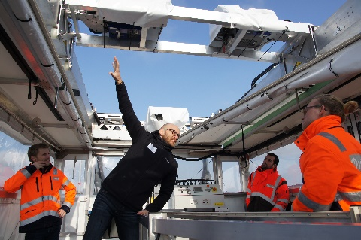
Presentation of the platform SYSTEM terra ©WINDEA Offshore
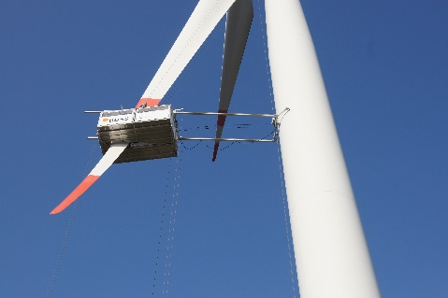
SYSTEM terra in operation ©WINDEA Offshore

